The 2022 UP-STAT Poster Competition will be held asynchronously, with participants posting their presentations online. As such, student “posters” will be recorded and may take the form of any presentation method deemed necessary (slide presentations as one example). These are to be two-minutes in length and must be uploaded by April 27th. We will utilize the Flipgrid platform, enabling you to post your video and interact remotely with conference attendees.

Section A: Where to access UP-STATS ‘22 Flipgrid Site
The UP-STAT poster competition will be hosted on Flipgrid. Please post your presentation at the link below:
https://flipgrid.com/132f1b93
PLEASE NOTE: You will need to log-in using either a Gmail or Microsoft Account

Section B: Anatomy of Flipgrid Camera
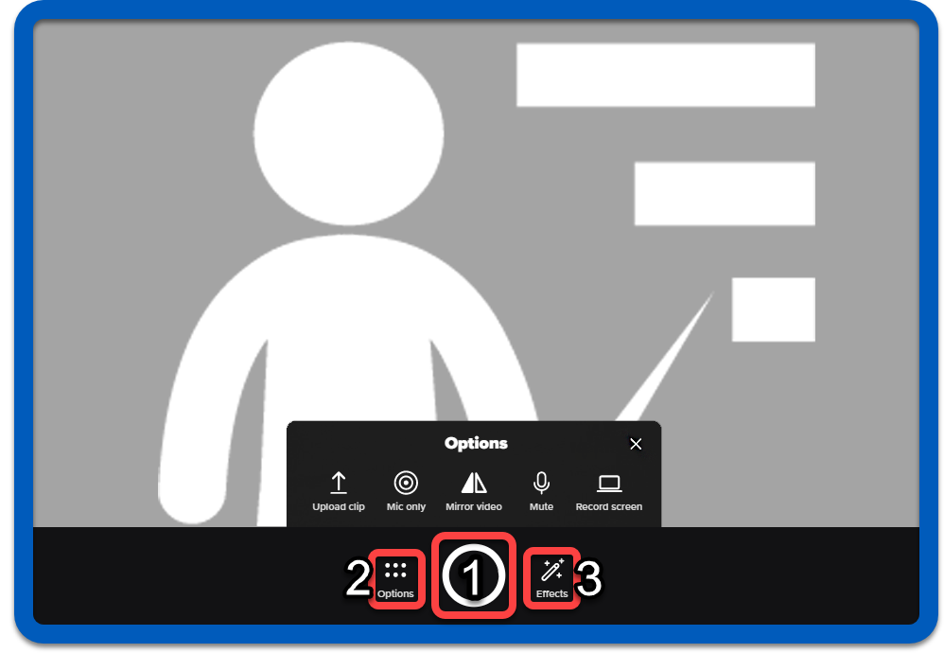

1. Record/Pause button
Press this to start recording, or to pause and catch your breath!
2. Options drawer
Upload video clips, Flip the camera & Share your screen

3. Effects drawer
Add Filters, Pen annotations and more to your recording

See this guide for more information on Flipgrid features and effects.

Section C: How do I record using Flipgrid?
This method is preferred for solo Presentations.
- Navigate to the Flipgrid site.

Figure 1
NOTE: If prompted to log in, click Join with Microsoft, or Join with Google using either a personal or institutional account.
- Click on the red Record a Response button (Fig. 2)

Figure 2
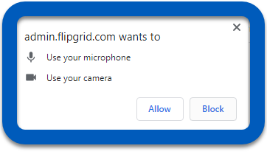
NOTE: When prompted by your browser, Allow Flipgrid to Use your microphone. (Fig. 3)

Figure 3

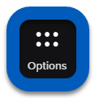
- You should now see the full Flipgrid Camera window. Click on Options to display camera controls and functions. (Fig. 4)

Figure 4
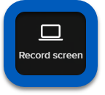
- Within the expanded menu, click Record Screen. (Fig. 5)

Figure 5
- Click Start Screen Recording button. (Fig. 6)

Figure 6
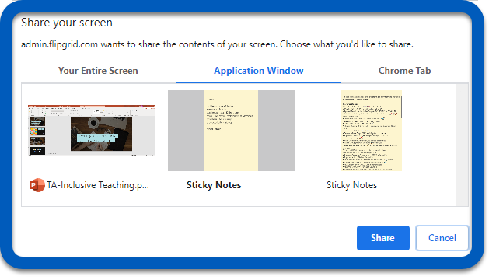
- Select the window or application to be recorded and click Share when ready. (Fig. 7)

Figure 7
NOTE: When recording, you may head to any application you wish to record - Google Slides, PowerPoint, or a website.
- When you are finished presenting, click Stop recording.
- Click Next.
- Fill out the Display Name and Description fields
- Click Submit to finalize and post your completed video. (Fig. 8)
Figure 9
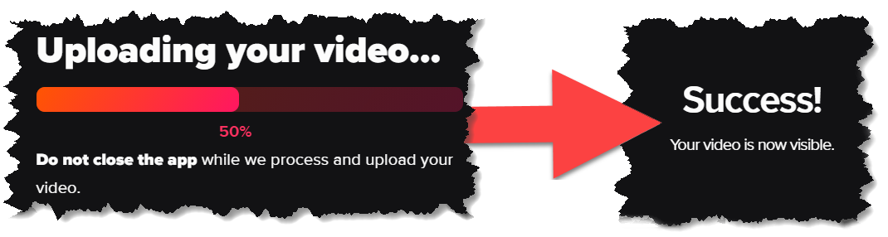
- Wait for the upload process to complete and click Done to complete the process.

Section D: How do I record Using Zoom & Upload to Flipgrid?
This method is particularly suited to group/team presentations.
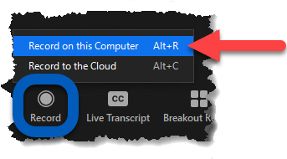
- While hosting a Zoom session with your fellow contributors, click on the Record button and select Record on this Computer or press Alt + R. (Fig. 10)

Figure 10
NOTE: When recording a shared screen in Zoom, you may head to any application you wish to record - Google Slides, PowerPoint, or a website. See this guide for help sharing your screen in Zoom.

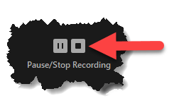
- Present with your peers and press on the Stop button to end the recording. (Fig. 11)

Figure 11

- End the meeting to save the finished recording.
NOTE: Your save folder will automatically open featuring several versions of the recording. Keep this popup open for later reference. The video will be titled “zoom_0.mp4”
- Open an internet browser & navigate to the Flipgrid site.

Figure 12
NOTE: If prompted to log in, click Join with Microsoft, or Join with Google using either a personal or institutional account.
- Click on the red Record a Response button (Fig. 13)

Figure 13

NOTE: When prompted by your browser, Allow Flipgrid to Use your microphone. (Fig. 14)

Figure 14

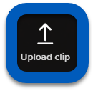
- You should now see the full Flipgrid Camera window. Click on Upload clip. (Fig. 15)

Figure 15
- Click on Upload Video to bring up the file explorer. Manually locate the video file and Open/Select to begin the upload process. Alternatively, you may click and drag the video from the folder location.
- Click Next.
- Fill out the Display Name and Description fields
- Click Submit to finalize and post your completed video. (Fig. 16)
Figure 16
- Wait for the upload process to complete and click Done to complete the process.

Additional Details:
- Flipgrid currently supports MP4, MOV, and WEBM video formats.
- The maximum size of an import is 500 mb.
- Chromebooks do not support MOV files.
- We recommend the web browser or app is up to date to avoid any importing issues.
- Having Issues with a Recorded Video? We recommend using a free program, such as https://convert-video-online.com/, to convert the video to 720p quality.

Section E: How do I view other Submissions?
- Open an internet browser and navigate to the Flipgrid site.

Figure 17
NOTE: If prompted to log in, click Join with Microsoft, or Join with Google using either a personal or institutional account.
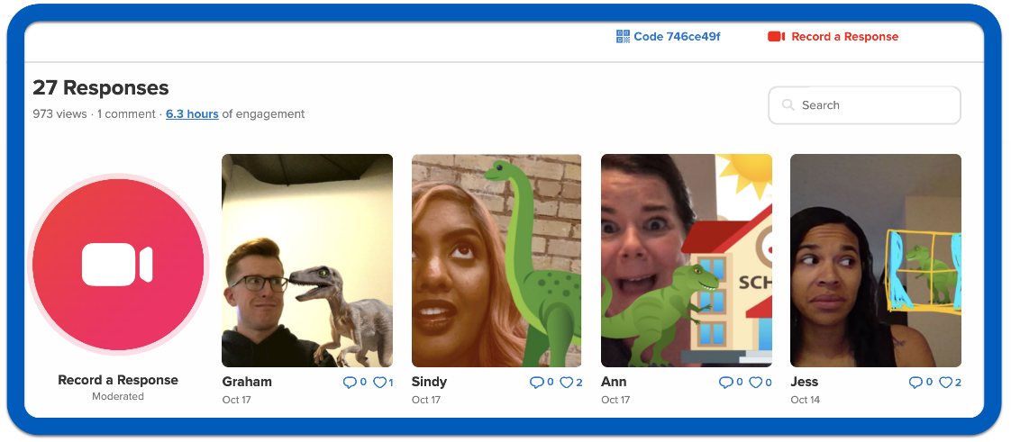
- Click on the thumbnail image of a video to view. (Fig. 18)

Figure 18

Section F: How do I comment on other Flipgrid Submissions?
You can reply to a video with a video comment, text comment, or a text comment with a video comment. Text comments are limited to 500 characters of plain text.
- Open the desired video Response
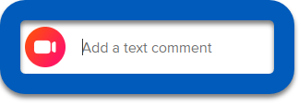
- Select the Add a Comment button below the video. (Fig. 19)

Figure 19
- Enter the text comment and press Enter or the send icon
If the student attempts to submit a comment that contains potentially inappropriate words or phrasing, Flipgrid will automatically prevent the comment from being submitted and alert the student to update the comment.
- ALTERNATIVELY: click on the Recorder Button to record a video response. (Fig. 20)

Figure 20
NOTE: For additional guidance with Recording, see Section C: How do I record using Flipgrid?

